Project 1: Pick and Place with a Fixed Manipulator
1. Project description
This project focuses on a fixed 7-DoF Jaco v2 robotic arm placed between two tables in a predefined SDF environment. At the start of the simulation, several movable objects (three cubes and two cylinders) rest on the source table, while the target table is initially empty.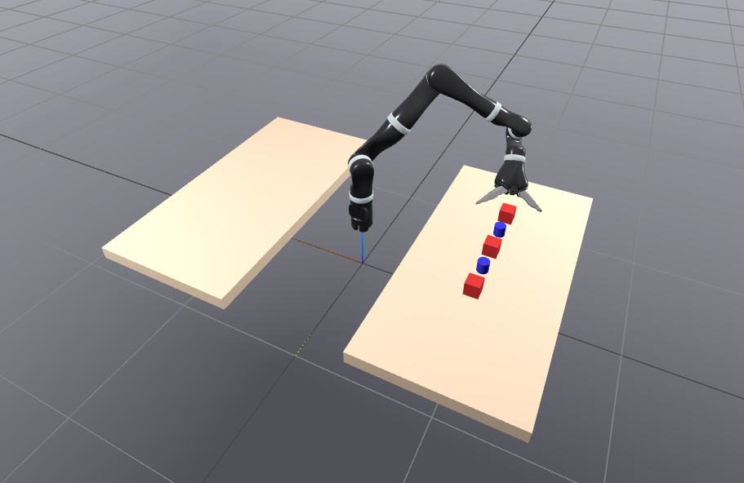
Figure 1: Students are provided with an SDF scene containing the robot, tables, and objects.
Objective:
Design and implement a control strategy that enables the manipulator to pick up all the objects from the source table and place them on the target table efficiently and without collisions.
Your solution should demonstrate:
- Repeatability: consistent performance for multiple randomized object layouts.
- Robustness: tolerance to small model or pose variations.
2. Provided material
Students receive an SDF world file (pick_and_place_world.sdf) containing:
- The Jaco v2 robot URDF (fixed base).
- Two static tables (source and target).
- Five dynamic objects with predefined mass, friction, and geometry properties.
- A ground plane.
This file defines all the necessary visual, collision, and physical properties. You only need to load it and control the robot programmatically through Drake.
Expected Implementation
Students must:
- Load and visualize the SDF world in Drake using the MultibodyPlant and MeshCat visualizer.
- Identify and manipulate individual objects via their model instances.
- Design a motion or control strategy to perform the pick-and-place sequence.
- Plan grasp and placement poses for each object, ensuring feasible and collision-free trajectories.
- Simulate and validate the entire sequence, recording total execution time and ensuring stable object transfers.
Notes
- You are not required to modify the SDF structure.
- Object positions can be randomized at initialization to demonstrate robustness.
- Focus on achieving smooth, collision-free motion and practical grasp placement strategies rather than highly complex planning algorithms.

Project 2 – Trajectory following with a mobile robot
Project Description
In this project, a Clearpath Husky A200 mobile robot acts as a follower that must track a dynamically moving reference (leader). The reference follows a sinusoidal infinity-shaped trajectory that defines the planar (x, y) motion in a flat environment, while maintaining a fixed distance of 2 cm between the follower and the leader marker.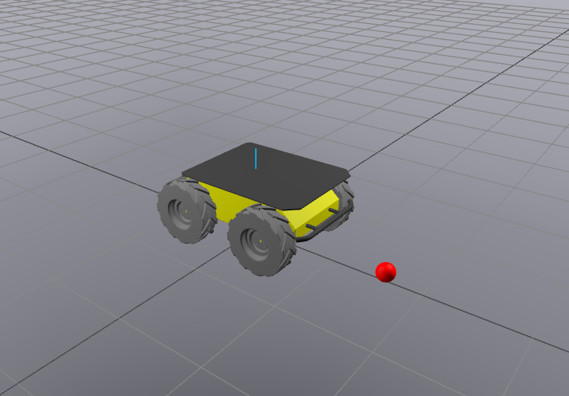
Objective:
Design a control strategy that ensures stable, accurate, and oscillation-free tracking of the moving target.
The Husky robot is non-holonomic and differentially driven, meaning its base motion is constrained by wheel actuation.
Students must reason about the mapping between wheel velocities and robot base pose, designing a feedback controller that reacts dynamically to the moving reference.
Provided Material

3. Expected Implementation
Students must:
- Load and visualize the provided SDF world in Drake.
- Model the kinematics of the non-holonomic Husky robot.
- Implement a trajectory tracking controller that enables the robot to follow the leader marker accurately.
- Ensure the motion is smooth and stable, maintaining the 2 cm following distance.
- Validate and visualize the motion, recording key metrics such as position error and velocity profiles.
Notes
- You are not required to modify the SDF structure.

Project 3 – Robot drawing using a one-point endeffector
Project description
A 7DOF robot manipulator (Franka emika Panda robot) with a pen shaped end effector, is tasked to draw initials in a white board.
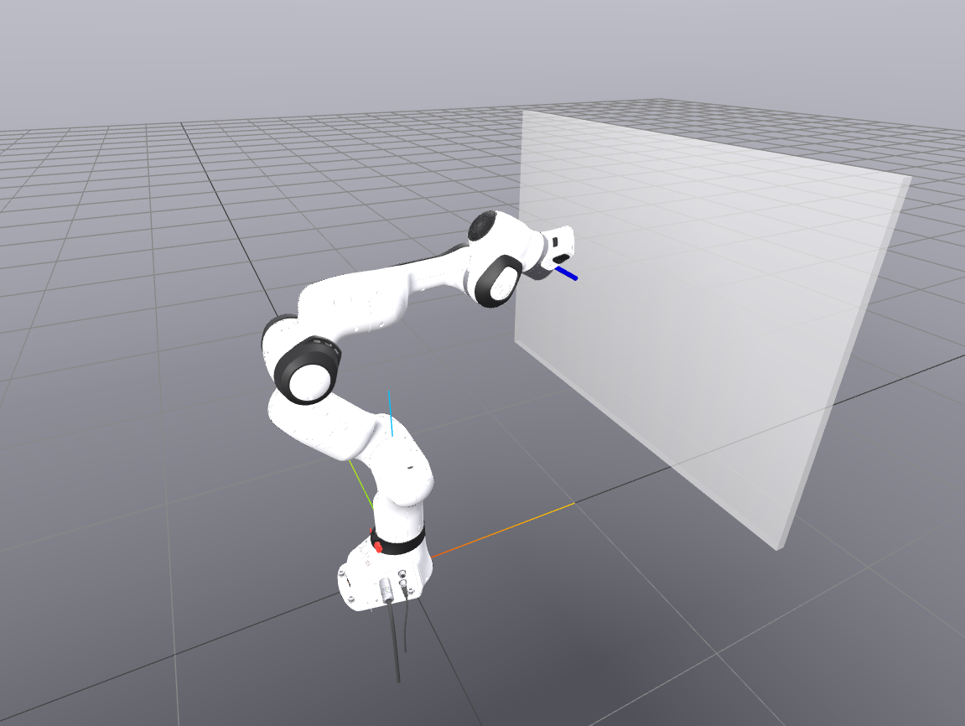
Provided Material
<?xml version="1.0" ?>
<sdf version="1.6">
<world name="drawing_world">

<!-- ============================= -->
<!-- Robot Manipulator (Franka) -->
<!-- ============================= -->
<include>
<uri>file://../models/descriptions/robots/arms/franka_description/urdf/panda_arm.urdf</uri>
</include>
<joint name="world_to_robot" type="fixed">
<parent>world</parent>
<child>panda::panda_link0</child>
<!-- slightly move the robot base away from the wall/board -->
<pose>0 0 0 0 0 0</pose>
</joint>

<!-- ============================= -->
<!-- Pen end-effector -->
<!-- ============================= -->
<model name="pen_endeffector">
<pose>0 0 0.15/2 0 0 0</pose>
<link name="pen_link">
<inertial>
<mass>0.01</mass>
</inertial>
<visual name="pen_visual">
<geometry>
<cylinder>
<radius>0.005</radius>
<length>0.1</length>
</cylinder>
</geometry>
<material>
<diffuse>0.0 0.0 1.0 1.0</diffuse> <!-- blue pen tip -->
</material>
</visual>
<collision name="pen_collision">
<geometry>
<cylinder>
<radius>0.005</radius>
<length>0.1</length>
</cylinder>
</geometry>
</collision>
</link>
</model>

<!-- Attach the pen to the Panda's end-effector -->
<joint name="pen_fixed_joint" type="fixed">
<parent>panda::panda_link7</parent>
<child>pen_endeffector::pen_link</child>
</joint>

<!-- ============================= -->
<!-- Drawing Board -->
<!-- ============================= -->
<model name="whiteboard">
<static>true</static>
<!-- Position slightly in front of the robot -->
<pose>0.6 0 0.6 0 0 1.5708</pose>
<!-- rotated 90° around Y axis to make it vertical -->
<link name="board_link">
<visual name="whiteboard_visual">
<geometry>
<box>
<size>1.0 0.02 0.7</size> <!-- width, thickness, height -->
</box>
</geometry>
<material>
<diffuse>1.0 1.0 1.0 0.4</diffuse> <!-- white color -->
<specular>0.2 0.2 0.2 1.0</specular>
</material>
</visual>

<collision name="whiteboard_collision">
<geometry>
<box>
<size>1.0 0.02 0.7</size>
</box>
</geometry>
<drake:proximity_properties>
<drake:mu_dynamic>0.4</drake:mu_dynamic>
<drake:mu_static>0.4</drake:mu_static>
</drake:proximity_properties>
</collision>
</link>
</model>

</world>
</sdf>

Expected Implementation

Project 4 – Conveyor Belt Sorting with a Fixed Manipulator
Project description
A 7-DoF manipulator is positioned beside a conveyor belt carrying multiple objects (different shapes or colors). The robot must pick each object as it arrives and sort it into designated bins.
Provided Material
- SDF world including the robot, a moving conveyor belt, and multiple objects.
- Object positions and conveyor speed defined in a trajectory file.
Expected Implementation
- Load and visualize the conveyor scene in Drake.
- Track moving objects on the conveyor and compute grasp poses.
- Implement a control strategy to pick objects and place them in bins without collisions.
- Validate simulation with timing and robustness measures.

More project ideas:
- Project 5 – Dual Arm Reaching Multiple Targets: Two 7-DoF manipulator must sequentially reach multiple target points in 3D space. Targets may represent buttons, sensors, or inspection points. The robot must plan smooth, collision-free motions while completing the task efficiently.

